**KING’S COLLEGE – BUDDO**

# **UCE INTERNAL MOCK EXAMINATIONS 2020**

**535/1 PHYSICS**

##### **PAPER 1**

**TIME: 2 HOURS 15 M**

**Attempt all questions in section A and B**

1. **In section A: write the letter of the correct answer in the box on the right hand side**
2. **In section B: write the answers in the spaces provided.**

## **Where necessary use the following constants**

**Acceleration due to gravity, g = 10ms –2**

**Speed of light in vacuum = 3.0 x 108 ms –1**

**Specific heat capacity of water = 4200 J kg –1 k –1**

**Specific latent heat of ice = 3.34 x 105 Jkg –1**

**Specific latent heat of steam = 2.26 x 106 Jkg –1**

**Speed of sound in air = 330ms – 1**

**SECTION A: (40 MARKS)**

1. The product of mass and acceleration is
2. Force.
3. inertia
4. velocity
5. Momentum.
6. A dull black surface is a good
7. Absorber of heat energy.
8. emitter of heat energy
9. Reflector of heat energy.
10. (i) only
11. (ii)and(ii)only
12. (ii) and (iii) only.
13. (i),(ii) and (iii).

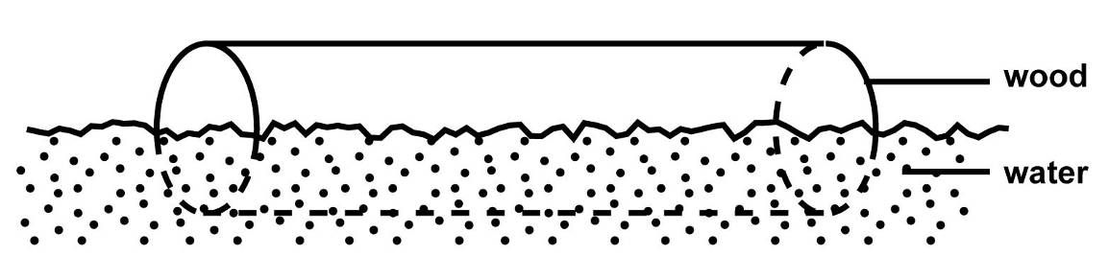

fig.1

Figure 1 shows a block of wood of volume 40 cm3 floating in water with only half of its volume submerged. Find the density of water is 1000 kg m-3, determine the mass of the wood under water.

1. 40 x 1000 kg.
2. 20 x 1000 kg.
3. 40 x 10-6 x 500 kg.
4. 20 x 10-6 x500 kg.
5. Surface tension in a liquid may be weakened by

A. lowering the temperature

B. adding soap solution

C. increasing the amount of the liquid

D. increasing the density of the liquid

1. A crane lifts 4 bricks per minute through a height of 1.5m. Find the power that is expended if each brick weighs 100N

A. 10.0W B. 215W C. 150W D. 600W

1. When a car is suddenly brought to rest, a passenger jerks forward because of

A. Friction B. Gravity C. Momentum D. Inertia

1. A ball thrown vertically upwards returns to the point of projection 12 seconds later. Calculate the speed with which the ball was thrown.

A. 10 m/s B. 30 m/s C. 60 m/s D. 120 m/s

1. Which of the following statements is/are true about two equal forces **F** acting on a beam of length, ***l***shown below

F

F

1. the resultant force on the bar is zero
2. the forces cause a rotation effect
3. the forces act in opposite directions
4. the forces produce different turning effects

A. (i) only B. (ii) and (i) only

C. (i), (ii), and (iii) only D. (i), (ii) and (iv) only

1. Mercury forms spherical drops on a wooden bench because it

A. it viscous B. has a high cohesive force

C. has a high adhesive force D. has high density

1. A body of mass 5kg falls freely from a height of 15m above the ground. Calculate the kinetic energy when it is 6m above the ground

A. 75J B. 300J C. 450J D. 750J

1. A metal weighs 14N in air and 12N when completely immersed in a liquid of density 600kgm-3. The density of metal is

A. 2100 B. 4200 C. 8400 D. 1400

1. Radiation in Thermos flask is minimized by;

A. Cork. B. Vacuum C. Silvered surfaces D. Felt pad

1. A vibrator produces waves which travel a distance of 12m in 4s. If the frequency of Vibrator is 2Hz. What is the wave length of the waves?

A. 1.5m B. 3m C. 6m D. 24m

1. Find the force required to give a mass of 500g an acceleration of

2X10-2ms-2.

1. 1 X 10-2 N
2. 1 X 101N
3. 1X102N
4. 1 X 104N

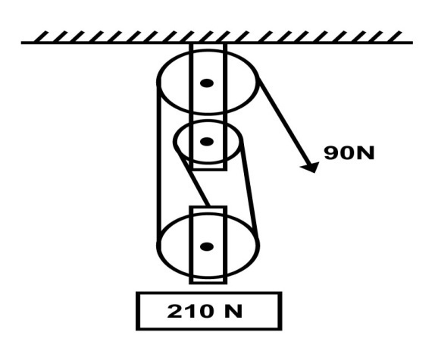

What is the velocity ratio of the pulley system above?

1. 1
2. 2
3. 4
4. 3
5. A concave mirror can be used as a shaving mirror because when an object is placed between the focus and the pole, the image formed is.

A. Magnified, real and erect

B. Magnified, real and inverted

C. Diminished, real and inverted

D. Diminished, virtual and erect.

1. When pressure of 1m3 of a gas at -73 oC is increased to 3 times its initial value, the temperature becomes 27 oC . Find the new volume of the gas
2. 0.22m3
3. 0.5 m3
4. 4.0 m3
5. 4.5 m3
6. The half life of uranium is 24 days calculate the mass of uranium which remains after 120 days if the initial mass is 64g:
7. 2g
8. 4g
9. 6g
10. 5g
11. Which of these is a brittle material?
12. Rubber
13. Plastic
14. Glass
15. Copper
16. Which one of the following does not change when water waves travel from deep to shallow water?

A. Frequency B. Amplitude C. Velocity D. Wavelength

1. Which of the following physical quantities changes when body is moved from Earth to moon?

A. Mass B. Volume C. Weight D. Density

1. Which of the following shows the correct stages in an internal combustion engine?

A. Compression Power Exhaust Induction.

B. Exhaust Induction compression Power

C. Induction Power compression Exhaust

D. Induction Compression power Exhaust

1. Surface tension in a liquid may be weakened by
2. lowering the temperature.
3. adding soap solution
4. increasing the amount of liquid.
5. increasing the density of the liquid.
6. A nickel nuclide, contains
7. 28 protons and 28 neutrons.
8. 32 electrons and 28 neutrons.
9. 28 protons and 32 neutrons.
10. 28 electrons and 32 protons.
11. An object 6 cm high is placed 24 cm from a tiny hole in a pinhole camera. If the distance from the hole to the screen is 8 cm, find the size of the image on the screen.
12. 0.2 cm.
13. 2.0 cm
14. 18.0 cm
15. 32.0cm.
16. Two appliances are rated 240 V, 2kw and 240 V, 500 W. find the cost of running these appliances for 3 hours if one unit of electricity costs Shs70.
17. Shs 105.
18. Shs 175.
19. Shs 420.
20. Shs 525.
21. When does the eclipse of the moon occur?
22. When the moon is between the sun and the earth.
23. When the earth is between the sun and the moon.
24. When the sun is totally eclipsed by the moon.
25. When a bright ring of sunlight shows round the edge of the moon
26. A cell of e.m.f *1.5V* and internal resistance *r* is connected in series with a resistor of *5Ω* as shown in figure1 below.

***5 Ω***

***1.5 V***, ***r***

***Fig. 1***

If the current in the circuit is *0.25 A*, find the value of *r*.

A. 1*Ω* B. 6*Ω* C. 11*Ω* D. 16*Ω*

1. A bullet of mass 0.1Kg is fired from a rifle of mass 5Kg. The rifle recoils with a velocity of 16m/s. calculate the *velocity* with which the bullet is fired.

A. 66m/s B. 110m/s C. 210m/s D. 800m/s

1. An engine exerts a force of 200N at a speed of 15m/s. Find the power developed in KW.

A. 30,000 B. 3,000 C. 300 D. 30

1. Temperatures charge and mass are examples of

A. Fundamental quantities B. Derived quantities

C. Vector quantities D. Scalar quantities

1. Electrical energy can be converted to heat energy by means of

A. a thermopile B. a thermometer

C. an electric iron D. an electric fan

1. The rate of evaporation from a body does not depend on

A. temperature of the liquid B. pressure at a time

C. dryness of air around the body D. nature of the liquid

1. Metals are good conductors of heat because;
2. They contain free electrons
3. They contain free protons
4. They are ductile
5. Their atoms can be easily displayed
6. A step down transformer

A. decreases current

B. decreases both current and voltage

C. decreases voltage

D. doesn’t alter current



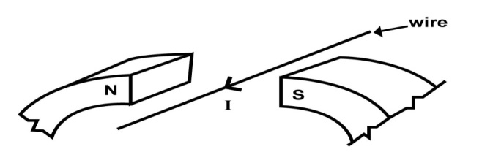

Fig.5

When a current 1, flows through a wire placed in between the poles of

a U – magnet as shown in figure 5, the wire move

1. up wards.
2. downwards.
3. towards the south pole.
4. towards the north pole.
5. When a metal sphere is dropped in a viscous fluid, it eventually attains a steady velocity called

A. turbulence velocity B. terminal velocity

C. viscous velocity D. average velocity

1. The gradient of a velocity – time graph represents the

A. speed of the body B. velocity of the body

C. acceleration of the body D. the distance covered by the body

1. The amount of heat required to raise the temperature of 0.5kg of salt solution from -5oC to 15oC is (specific heat capacity of salt solution is 4000 J Kg-1 K-1)

A. 8000J B. 20,000J C. 40,000J D. 160,000J

**SECTION B: (40 MARKS)**

1. (a) state Hooke’s law [1]

......................................................................................................................................................................................................................................................................................................

(b) What is meant by the terms; [2]

(i) ties

......................................................................................................................................................................................................................................................................................................

1. struts

..............................................................................................................................................................................................................................................................................

(c) State one factor that affect the strength of a material [1]

......................................................................................................................................................................................................................................................................................................

1. (a) what is meant by the term Brownian motion [1]

......................................................................................................................................................................................................................................................................................................

(b) Explain briefly what would happen if the temperature of the smoke cell was reduced [2]

......................................................................................................................................................................................................................................................................................................

...................................................................................................................................................

(c) State one application of capillarity [1]

......................................................................................................................................................................................................................................................................................................

1. (a) state Ohm’s law [1]

......................................................................................................................................................................................................................................................................................................

(b) A filament lamp is rated 50W, 240V. What is the meaning of this statement? [1]

......................................................................................................................................................................................................................................................................................................

(c) A bulb rated 75W is lit for 12hours a week, estimate the total amount of money spent on electricity bill due to this bulb weekly. [2]

......................................................................................................................................................................................................................................................................................................

......................................................................................................................................................................................................................................................................................................

1. (a) Define the term temperature [1]

......................................................................................................................................................................................................................................................................................................

(b) In an experiment to show expansion in liquids, the set up below was used

1. State what was observed when the temperature of water in the glass beaker is gradually increased. [1]

........................................................................................................................................................................................................................................................................................

1. Explain the observation in (i) above [2]

......................................................................................................................................................................................................................................................................................................

......................................................................................................................................................................................................................................................................................................

1. (a) what is mass [1]

......................................................................................................................................................................................................................................................................................................

(b) A body of mass 200g has a volume of 500cm3. Find the density of the body. [3]

......................................................................................................................................................................................................................................................................................................

......................................................................................................................................................................................................................................................................................................

1. (a) define half-life of a material [1]

......................................................................................................................................................................................................................................................................................................

(b) An element decays and turns to Y with emission of an alpha particle.

(i) Write a balanced equation to show the reaction [2]

......................................................................................................................................................................................................................................................................................................

(ii) Describe the composition of element Y [1]

......................................................................................................................................................................................................................................................................................................

1. (a) define the term frequency [1]

......................................................................................................................................................................................................................................................................................................

(b) (i) A radio station broadcasts its programs on a frequency of $1×{10}^{5}Hz$. If the wavelength of the signal is $3000m$ calculate the velocity of the signal [2]

......................................................................................................................................................................................................................................................................................................

......................................................................................................................................................................................................................................................................................................

(ii) State one application of echoes [1]

......................................................................................................................................................................................................................................................................................................

1. (a) State Archimede’s principle [1]

......................................................................................................................................................................................................................................................................................................

(b) State any two applications of the law of floatation [1]

......................................................................................................................................................................................................................................................................................................

(c) A body of mass 6kg and density 1200kgm-3 is completely immersed in a liquid of density 800kgm-3. Find the upthrust on the body. [2]

......................................................................................................................................................................................................................................................................................................

......................................................................................................................................................................................................................................................................................................

1. (a) define the term power of a lens [1]

......................................................................................................................................................................................................................................................................................................

(b) State two properties of images formed by diverging lens [1]

......................................................................................................................................................................................................................................................................................................

(c) The focal length of a convex lens is 10cm; find the power of the lens [2]

......................................................................................................................................................................................................................................................................................................

1. (a) define the term diffusion [1]

........................................................................................................................................................................................................................................................................................ (b) State two applications of capillarity [2]

......................................................................................................................................................................................................................................................................................................

(c) State one reason why efficiency of a machine is always less than 100% [1]

......................................................................................................................................................................................................................................................................................................

**END**